PROTECTION AND PERMANENCY MEMORANDUM, 14-17

TO: Service Region Administrators
Service Region Administrator Associates
Service Region Clinical Associates
Regional Program Specialists
Family Services Office Supervisors

FROM: Tina Webb, Assistant Director
Division of Protection and Permanency

DATE: December 12, 2014

SUBJECT: Merge of the DPP-1263 and DPP-1292 and Documenting Child’s Address for Relative Placements

The purpose of this memorandum is to introduce a new form that will contain pertinent content from the DSS-1263 Title IV-E Child Support and Change of Status form and the DPP-1292 Information for OOHC Placements and to clarify for staff how to appropriately enter a child’s address into c-TWIST when he/she is placed with a relative:

- Form merge: The DSS-1263 Title IV-E and Child Support Change of Status and the DPP-1292 Information for OOHC Placements have been merged in order to streamline the placement process for staff. Since much of the information on the DSS-1263 was obsolete, the relevant information from that form has been merged with the existing content from the DPP-1292 and it has been assigned a new form number, DPP-1279 Information for OOHC Placements. Please begin using this form immediately.

- Entering children placed with relatives into TWIST: When a child is placed in the custody of relatives, the child’s address should reflect the relative’s address for proper tracking and reporting reasons, however, this information should not be placed in the “Enter/Exit” screens in TWIST. Instead, the address is listed in the “Individual Information” screen and can be accessed by following the directions below:
- Select the child’s “Individual Information” screen in c-TWIST by choosing “Screens,” “Individual,” “Individual Information,” “Ind Info” as shown below:
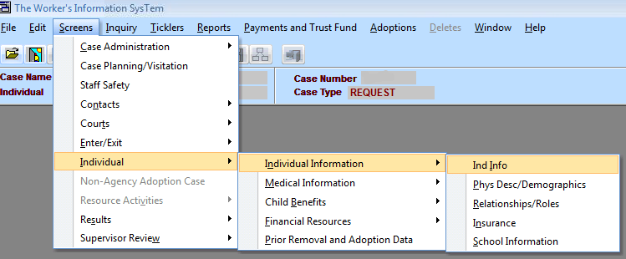

- Select the child whose information you wish to update and click OK:
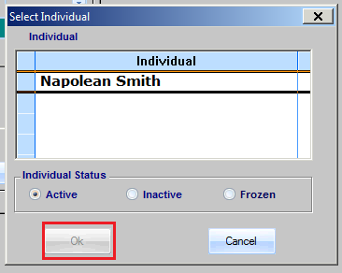

- Click on “Address” on the bottom, left of the screen:
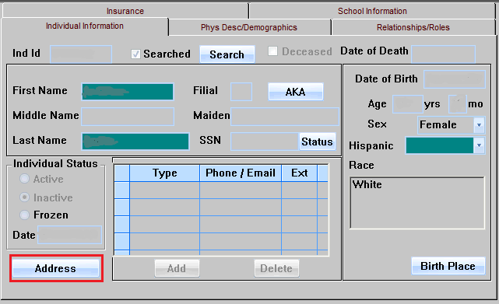

- Select the “Current Address” tab, click on the “Location” radio button and enter the relative’s address where the child resides:
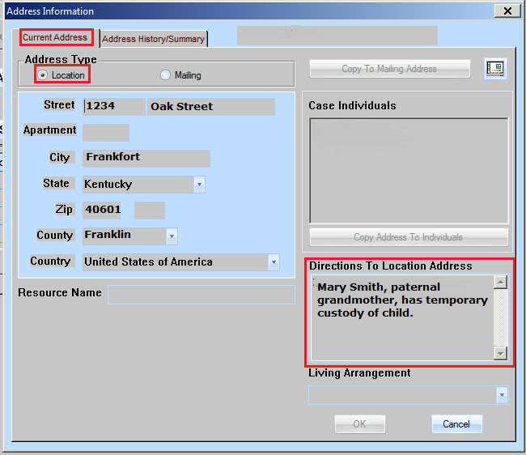

- In the box titled “Directions to Location Address,” include the statement, similar to the one above, which explains that the relative has custody.

If you have any questions regarding the form merge, please contact:
Jennifer Blair, Division of Financial and Administrative Management
Jennifer.blair@ky.gov
(270) 687-7047, ext. 2716

If you have any questions regarding the TWIST instructions for relative placements please contact:
Lucie Estill, Internal Policy Analyst
Lucie.estill@ky.gov
(502) 564-2136, ext. 3568

